Intersecting Lines
# Source: AI Source: Provided by: [Data Path: Persons Table -> ID Column: 1, Name_En Column: Motasem Essam] -> From: [ChatGPT] on [7/25/2026]
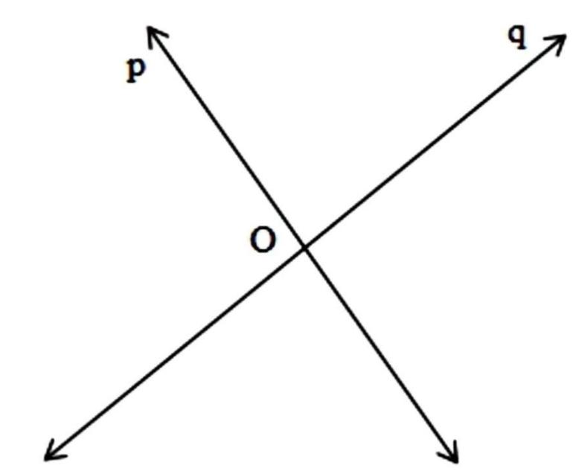
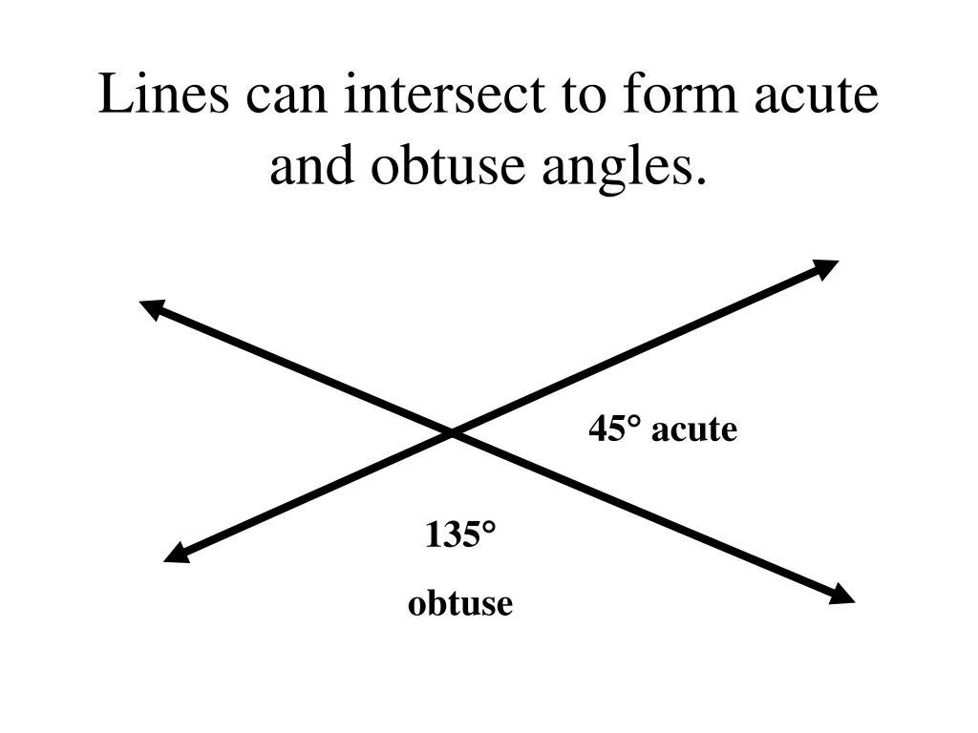
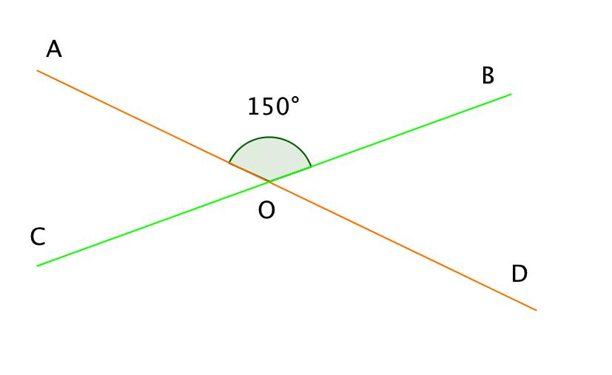
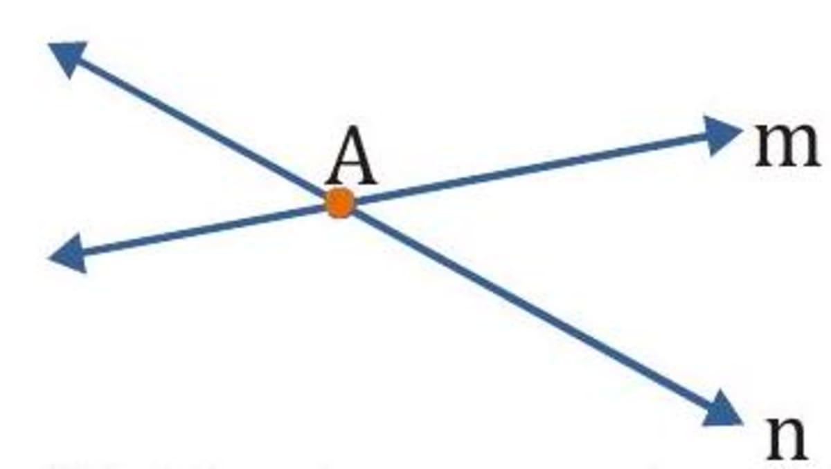
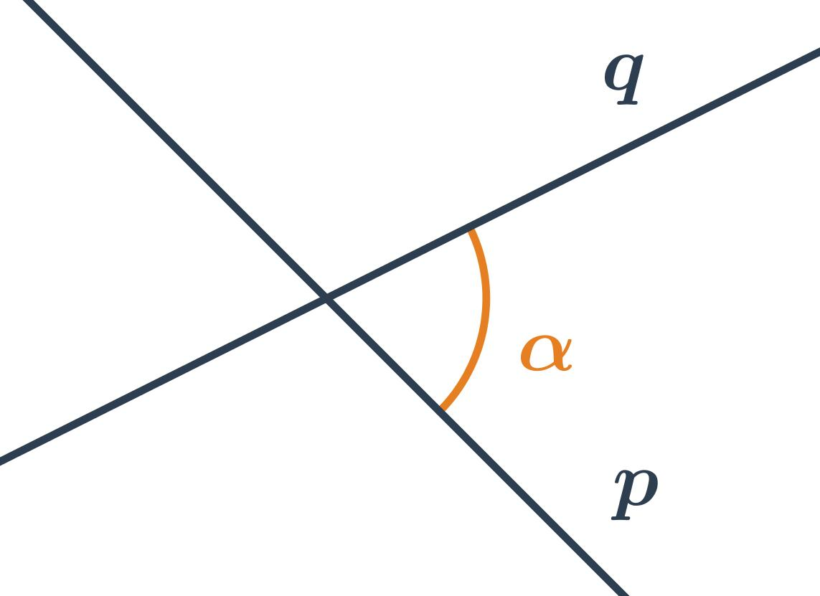

Definition
# Source: AI Source: Provided by: [Data Path: Persons Table -> ID Column: 1, Name_En Column: Motasem Essam] -> From: [ChatGPT] on [7/25/2026]
Intersecting Lines are two or more lines that cross each other at a common point. The point where they meet is called the point of intersection.
Unlike parallel lines, intersecting lines always have exactly one common point when considered in the same plane.

Characteristics
# Source: AI Source: Provided by: [Data Path: Persons Table -> ID Column: 1, Name_En Column: Motasem Essam] -> From: [ChatGPT] on [7/25/2026]
Intersecting lines:
- Meet at exactly one point.
- Form four angles at the point of intersection.
- May intersect at any angle.
- Can be perpendicular if the intersection angle is 90°.
- Are coplanar (lie in the same plane).

Illustration
# Source: AI Source: Provided by: [Data Path: Persons Table -> ID Column: 1, Name_En Column: Motasem Essam] -> From: [ChatGPT] on [7/25/2026]
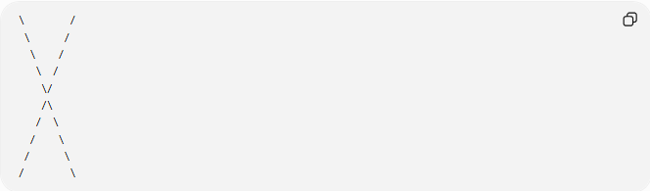
\ /
\ /
\ /
\ /
\/
/\
/ \
/ \
/ \
/ \
The center is the point of intersection.

Mathematical Representation
# Source: AI Source: Provided by: [Data Path: Persons Table -> ID Column: 1, Name_En Column: Motasem Essam] -> From: [ChatGPT] on [7/25/2026]
If two lines $l_{1}$and $l_{2}$intersect, their intersection can be written as:
$$l_{1}∩l_{2}=P$$
where:
- $P$is the point of intersection.

Coordinate Geometry
# Source: AI Source: Provided by: [Data Path: Persons Table -> ID Column: 1, Name_En Column: Motasem Essam] -> From: [ChatGPT] on [7/25/2026]
Two lines intersect if they have different slopes.
Given:
$$y=m_{1}x+b_{1}$$
and
$$y=m_{2}x+b_{2}$$
the lines intersect when:
$$m_{1}≠m_{2}$$
If:
$$m_{1}=m_{2}$$
they are either parallel or coincident.

Examples
# Source: AI Source: Provided by: [Data Path: Persons Table -> ID Column: 1, Name_En Column: Motasem Essam] -> From: [ChatGPT] on [7/25/2026]
Examples of intersecting lines include:
- Two roads crossing at an intersection.
- The diagonals of a rectangle.
- The hands of a clock (except when parallel).
- Scissors when partially open.
- Crossing beams in a bridge.

Properties
# Source: AI Source: Provided by: [Data Path: Persons Table -> ID Column: 1, Name_En Column: Motasem Essam] -> From: [ChatGPT] on [7/25/2026]
Intersecting lines:
- Share exactly one common point.
- Form four angles.
- Opposite (vertical) angles are equal.
- Adjacent angles are supplementary (sum to ${180}^{∘}$).
- Can intersect at any angle from $0^{∘}$to ${180}^{∘}$(exclusive), except when parallel.

Special Case
# Source: AI Source: Provided by: [Data Path: Persons Table -> ID Column: 1, Name_En Column: Motasem Essam] -> From: [ChatGPT] on [7/25/2026]
If intersecting lines meet at:
$${90}^{∘}$$
they are called Perpendicular Lines.
Thus, every pair of perpendicular lines is intersecting, but not every pair of intersecting lines is perpendicular.

Applications
# Source: AI Source: Provided by: [Data Path: Persons Table -> ID Column: 1, Name_En Column: Motasem Essam] -> From: [ChatGPT] on [7/25/2026]
Intersecting lines are used in:
- Plane Geometry
- Coordinate Geometry
- Engineering
- Architecture
- Construction
- Surveying
- CAD (Computer-Aided Design)
- Computer Graphics
- Road Design
- Structural Design

Advantages
# Source: AI Source: Provided by: [Data Path: Persons Table -> ID Column: 1, Name_En Column: Motasem Essam] -> From: [ChatGPT] on [7/25/2026]
Studying intersecting lines helps to:
- Analyze angle relationships.
- Solve geometric constructions.
- Determine intersection points.
- Model crossing structures.
- Support coordinate geometry calculations.

Limitations
# Source: AI Source: Provided by: [Data Path: Persons Table -> ID Column: 1, Name_En Column: Motasem Essam] -> From: [ChatGPT] on [7/25/2026]
Intersecting lines:
- Must lie in the same plane.
- Cannot remain equidistant like parallel lines.
- Share only one intersection point.

Comparison with Other Types of Lines
# Source: AI Source: Provided by: [Data Path: Persons Table -> ID Column: 1, Name_En Column: Motasem Essam] -> From: [ChatGPT] on [7/25/2026]
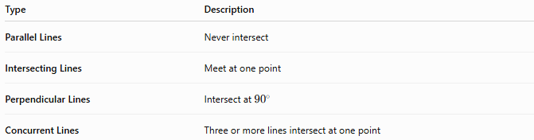
Type | Description
Parallel Lines | Never intersect
Intersecting Lines | Meet at one point
Perpendicular Lines | Intersect at ${90}^{∘}$
Concurrent Lines | Three or more lines intersect at one point

Key Points
# Source: AI Source: Provided by: [Data Path: Persons Table -> ID Column: 1, Name_En Column: Motasem Essam] -> From: [ChatGPT] on [7/25/2026]
- Intersecting Lines cross at exactly one point.
- The meeting point is called the point of intersection.
- They form four angles.
- Vertical opposite angles are equal.
- Perpendicular lines are a special type of intersecting lines.
- Intersecting lines are widely used in geometry, engineering, architecture, surveying, CAD, and computer graphics.

Conclusion
# Source: AI Source: Provided by: [Data Path: Persons Table -> ID Column: 1, Name_En Column: Motasem Essam] -> From: [ChatGPT] on [7/25/2026]
Intersecting Lines are lines that meet at a single point, creating four angles and establishing important geometric relationships such as vertical opposite angles and supplementary adjacent angles. They play a fundamental role in plane geometry, coordinate geometry, engineering, architecture, construction, surveying, CAD, transportation planning, and computer graphics, where identifying and analyzing intersections is essential for accurate design, measurement, and spatial reasoning.

